***In silico* evaluation and drug-likeness prediction of some thiadiazole derivatives as ULK1/2 inhibitors**

Parin Sidat1,2*, Malleshappa Noolvi2, Sanket Rathod3, Rahul Patil4, Prafulla Choudhari3, Raj Wagh 5, Vishal Beldar6

1PhD Scholar, Pharmacy branch, Gujarat Technological University, Ahmedabad, Gujarat, India

2Department of Pharmaceutical Chemistry, Shree Dhanvantary Pharmacy College, Kim-394110, Gujarat, India.

3Department of Pharmaceutical Chemistry, Bharati Vidyapeeth College of Pharmacy, Kolhapur, 416 013 (MS), India.

4Department of Pharmaceutics, Shree Dhanvantary Pharmacy College, Kim-394110, Gujarat, India.

5Department of Chemical Engineering, Institute of Chemical Technology Mumbai, Marathwada Jalna.

6Department of Pharmacognosy, Institute of Chemical Technology Mumbai, Marathwada Jalna.

**\*Corresponding Author-**

Parin Sidat (+91 9265554625)

ORCID iD-0000-0002-0583-8991

[parinsidat12@gmail.com](mailto:parinsidat12@gmail.com)

**Outline**

1. Introduction
2. Rationale
3. Material and methods
   1. Protein preparation
   2. Ligand preparation
   3. Molecular docking studies
   4. Pharmacophore analysis
   5. *In silico* ADMET and Druglikeness
   6. Bioactivity score
   7. Molecular dynamic simulation
4. Results and discussion
   1. Molecular docking
   2. Pharmacophore analysis
   3. *In silico* ADMET and Drug-likeness
   4. Bioactivity score
   5. Molecular dynamic simulation
5. Conclusion

**Abstract**

**Objective**

The current study focuses on the *In-silico* evaluation and molecular prediction of some thiadiazole derivatives as ULK (Human Autophagy Initiating Kinase) inhibitors.

**Methods**

Some thiadiazole derivatives were subjected to *In-silico* evaluation involving Molecular docking, Pharmacophore modelling, PASS prediction and Molecular dynamic simulation (MD) along with PCA analysis. In addition, drug-likeness was determined using the Lipinski rule of five**.**

**Result and Discussion**

Among all proposed thiadiazole derivatives, we found a few ligands such as 2d, 4e and 4d with the lowest binding energy score (-11.3 kcal/mol, -11.2 kcal/mol and -11.0 kcal/mol), respectively. Drug-likeness properties include an excellent lipophilic character with good permeability (1.97, 2.86 and 2.73) observed with the above derivatives. In addition, better binding specificity (94.79, 94.70 and 74.57) and better enzyme inhibitory activity (0.04, 0.00, 0.14) were noticed with ULK receptors in comparison to STD (Standard) molecules. Using pharmacophore modelling, we identified potential chemical features of the designed compounds. Moreover, molecular dynamics and PCA analysis of compound 4d showed stable conformation with 4WNP.

**Conclusion**

Compared to STD compounds, with no violation, the bioactivity and likeness score of ligands 2d, 4e, and 4d were relatively high, indicating that they were excellent ULK inhibitors. These ligands also had the lowest binding score, which may aid in determining the stability of ligands. Pharmacophore modeling data suggested the essential chemical features of designed compounds required for the activity. And the MD simulation and PCA study confirmed the stability of 4d complex with 4WNP. These parameters allow consideration of the most promising candidates to be synthesized.

**Keywords:** Molecular Dynamic simulation, Phamacophore modelling, Molecular modelling, PASS analysis, PCA analysis, Drug likeness Properties, Thiadiazole derivatives and ULK1/2 inhibitors.

**Graphical Abstract**

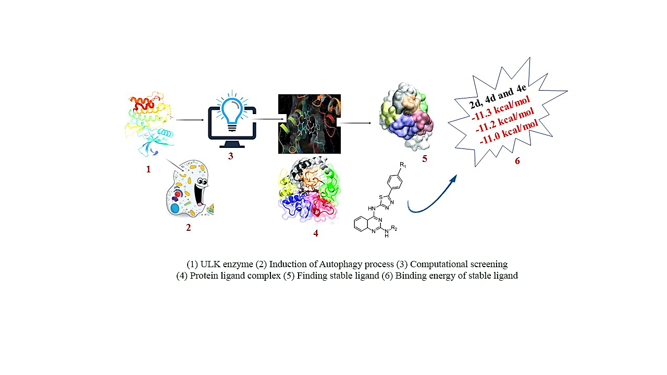

* 1. **Introduction**

Cancer is a group of diseases distinguished by uncontrollable cell division. It is caused by multifactorial, multigenic, and multi-pathway. Many targeted therapies are effective in treating cancer. Four broad categories of targeted therapies include monoclonal antibodies, small molecule inhibitors, antibody-drug conjugates, and immunotherapy 1. It is critical to develop tumour-targeted molecular therapies successfully to avoid misidentifying ideal targets. Herein, we are employing autophagic cell death therapy to target tumor cells. Mostly, starvation triggers Autophagy, but various stressors can also induce it. Autophagy is a multi-step lysosomal degradation process in which some long-lived proteins or damaged organelles in cells are degraded 2. Many proteins are involved in the autophagy process, including ULK1, ULK2, PDK1, ATG4B, VPS34, and ATG 3. Autophagy is well known to be modulated by some autophagy-related (ATG) genes, particularly UNC-51-like kinase 1 (ULK1), and it's complex. Kinases are essential in signaling pathways that modulate many physiological functions, including cell growth, proliferation, migration, and angiogenesis 4. Unc-51-like Autophagy activating kinase (ULK1/2) is an enzyme with two isoforms encoded by the ULK1/2 genes in humans. It is a kinase that participates in Autophagy, particularly in response to amino acid deprivation. Ulk1/2, related to ATG1 in yeast, is a protein involved in Autophagy in mammalian cells. It is a component of the ULK1 complex, which is required for autophagosome biogenesis in the early stages. The ULK1 complex also includes the FAK family kinase interacting protein of 200 kDa (FIP200 or RB1CC1) and the HORMA (Hop/Rev7/Mad2) domain-containing proteins ATG13 and ATG101 5. ULK1 appears to be the most important for Autophagy and is activated by several upstream signals during nutrient deprivation, followed by autophagy initiation 6. ULK1 and ULK2 have high functional redundancy; studies have shown that ULK2 can compensate for the loss of ULK1. When both ULK1 and ULK2 are mutated, nutrient-dependent Autophagy is completely inhibited. ULK1 has a slew of downstream phosphorylation targets that help to induce the isolation membrane/autophagosome 7. ULK1/2 is negatively regulated by [mTORC1](https://en.wikipedia.org/wiki/MTORC1) activity, active during anabolic-type environmental cues.

In contrast, ULK1/2 is activated by [AMPK](https://en.wikipedia.org/wiki/AMPK) activity from starvation signals 8. The protein ULK1 has a molecular weight of 112 kDa. It has an N-terminal kinase domain, a serine-proline-rich region, and a C-terminal interacting domain. Experiments have shown that the serine-proline-rich region is the site of phosphorylation by mTORC1 and AMPK; both are negative and positive regulators of ULK1 activity. The C-terminal domain contains two microtubule-interacting and transport (MIT) domains and serves as a scaffold connecting ULK1, ATG13, and FIP200 to form a complex required for Autophagy to begin. Early autophagy targeting/tethering (EAT) domains are composed of two three-helix bundles in the C-terminus and are organized as MIT domains. MIT domains also mediate interactions with membranes. The N-terminus contains a serine-threonine kinase domain. Between the N and C termini of ULK1, there is also a large positively charged activation loop. This region may be involved in kinase activity regulation and substrate recognition. ULK1 and ULK2 share significant homology in both the C-terminal and N-terminal domains 6. The heterocyclic moiety such as thiadiazole, quinazoline, and various aniline derivatives has been employed in this study to perform molecular docking against the "Human Autophagy Initiating Kinase” ULK. Heterocyclic compounds, like thiadiazole, are important pharmacologically active organic compounds with potential applications in medicinal chemistry. Some hybrid thiadiazole-based pharmacophore systems with anticancer activity have been reported in the literature. 2-Amino-1, 3, 4-thiadiazole have been identified as a promising scaffold for developing anticancer agents 9–11. Quinazoline has also shown potential anticancer activity 12–19. Some aniline derivatives, such as ortho-phenylenediamine, para-floro aniline, and pyrimidine-2-amine, contain an amine group, which aids in forming hydrogen bonds during amino acid binding 20–22. We also utilized the benzimidazole ring at the R2 position, and it has shown good anticancer activity on various cancer cell lines 23–28. This study aimed to investigate some hybrid structures containing thiadiazole, quinazoline, and aniline derivatives by using molecular docking, molecular dynamic simulation, and pharmacophore modelling virtual screening approaches to assess their potential biological activity. Altogether, we intend to design a proposed molecule that fulfils all pharmacophoric requirements so that we can utilize their potential application in medicinal chemistry.

* 1. **Rationale**

Wood and colleagues discovered a promising ULK inhibitor. All of them have a low IC50 value for the ULK protein 29. ULK protein has two terminal lobes, one on the N side chain and one on the C side chain, which is very specific for binding to the active side. The N-chain contains a serine-proline-rich region, which is the site of numerous regulatory phosphorylation by both mTORC1 and AMPK, which act as negative and positive regulators of ULK1 activity, respectively 6. Some amino acids, such as CYS95, TYR94, GLU93, LYS38, and MET92, are required to initiate phosphorylation. All amino acids interact with ULK at the hinge region, causing the confirmation to change from inactive to active 6. The inhibitor binds in the ATP binding site, making hinge contact with its pyrazole**.** These ULK play an essential role in the autophagy mechanism by inhibiting it via an active site containing the NH group of the benzimidazole moiety, which interacts with GLN142, and other benzene ring fragments, which interact with GLY98. In ULK-LN-1, the NH group between pyrazol and quinazoline forms an H bonding interaction with the carbonyl group of CYS95 amino acid. GLU93 and LYS38 were mutated at the N terminal side chain, and LYS162 is adjacent to this C terminal patch and is a known ULK1 regulatory site via acetylation by TIP60 30. This LYS162 residue makes several important contacts within the kinase, so acetylation of it could alter the conformation of the protien**.** The cyclobutyl substituent in the STD compound fits into a pocket adjacent to the gatekeeper methionine. This is the most fundamental pharmacophoric requirement for ULK inhibitory activity 8. Our goal is to design a molecule containing thiadiazole, quinazoline, benzimidazole, and aniline derivatives that fulfill all pharmacophoric requirements. Herein, we replaced pyrazole ring at R1 position with thiadiazole. The thiadiazole ring was selected for its dynamic role in pharmacokinetic and dynamic properties. Thiadiazole contains two N atoms with a high electron-donating ability and the ability to form H bonding interactions with ASN143 and GLN142, causing GLN142 to shift in position and reducing the transactivation mediated side effect 7.



**Figure 1:** ULK1/2 inhibitors and hypothetical model of the proposed molecule.

**Figure 2:** The designed quinazoline-thiadiazole and aniline derivatives hybrids.

* 1. **Material and methods**
  2. **Protein preparation**

The previously reported 3D crystal structure of ULK1 with PDB: 4WNP having 1.88 Å resolution was retrieved from the RCSB Protein data bank (<https://www.rcsb.org/>). Further, retrieved protein structure was cleaned and prepared by removing water molecules and naturally attached ligand groups. The protonation of cleaned protein was done by adding polar hydrogen atoms to define amino acids' correct ionization and tautomeric states. Cleaning of protein structure and preparation was done using BIOVIA Discovery Studio Visualizer 31. The prepared protein structure was then validated using the PROCHECK and ProSA-web server to determine the stereochemical acceptability and quality of cleaned protein 32,33. The binding pocket was predicted with the help of CASTp 3.0 server 34. Identified binding sites were used to predict the best ligand binding site in the respective target protein.

* 1. **Ligand Preparation**

Some novel thiadiazole derivatives were designed based on knowledge of various ULK analogues acting as an anticancer agent. The structures of compounds were drawn using ChemDraw Ultra 8.0 software; thereafter, designed structures were 3D using Chem3D Ultra 8.0 software. Allinger’s energy minimization technique energetically minimized converted 3D structures. Further, the molecular mechanics (MM2) force field was used to optimize the geometry. The ligand designing scheme is elaborated in (**Figu**r**es 1 and 2)**. Further, designed structures were named **1(a-e) to 8(a-e),** as displayed in **Table 1.** ALigand library of 46 compounds containing 40 newly designed compounds, five standard molecules from literature **(STD-1 to STD-5),** and naturally attached ligands in protein structure was prepared for the current study 3,6,29. 3D structures of standards were downloaded from PubChem (<https://pubchem.ncbi.nlm.nih.gov/>). The chemical structures of all the compounds present in the dataset are represented in **Table 1**. IUPAC names and SMILES of designed compounds are represented in **Supplementary Material Table S2.**

* 1. **Molecular docking studies**

Molecular docking was carried out to confirm the binding sites and interactions that occurred between the designed compounds and ULK1 as the target protein (PDB: 4WNP). Five ligands were selected from previously reported literature, and one naturally bound ligand was used as a standard compound. Molecular docking was performed with the help of the AutoDock Vina package of PyRx 0.8 software 35–38. The PDB file format of 4WNP as a macromolecule and the SDF file format of all designed compounds and all standards were imported in the Open Babel plugin PyRx. Further, all compounds were then subjected to energy minimization and converted to PDBQT format using the Open Babel. The grid box for the PDB: 4WNP was selected in the Vina workspace of PyRx to cover the binding site residues, with center X: 126.4941, Y: 40.8135, Z: 1.0241 and dimensions X: 88.3558128357 Å, Y: 52.7755333138 Å, Z: 79.5115510941 Å. The molecular docking procedure was started using the AutoDock Vina plugin of PyRx 36–38. The exhaustiveness was set to default at 8. Nine poses (conformations) were predicted for each compound with the selected target protein displayed. Docking interaction visualization and analysis of saved pose were carried out using the BIOVIA Discovery Studio Visualizer 31.

* 1. **Pharmacophore modelling**

The pharmacophore reflects the interacting molecule ecosystem of protein and ligand. Pharmacophore represents chemical features like hydrogen bond acceptor, hydrogen bond donor, lipophilic and aromatic contacts, which are responsible for the biological and functional response occurring when protein and ligand associate 39. The designed compounds were subjected to 3D pharmacophore model generation using PharmaGist (<https://bioinfo3d.cs.tau.ac.il/PharmaGist/>) and determination of pharmacophores was done based on input ligand molecules 40–44. Pharmacophores of designed compounds were generated in which one of the compounds served as a pivot on which the other subjected compounds were aligned. The user interface of PharmaGist is straightforward to handle 43. Designed compounds were converted to molecules in Sybyl Mol2 format using BIOVIA Discovery Studio and submitted on PharmaGist. After submitting the designed compounds, the pharmacophore detection algorithm started running. The results of PharmaGist were organized in tables by the number of aligned ligands along with their score in descending order. The model having the highest scoring is reported as a pharmacophore. Based on the physicochemical features and pharmacophore score, the best pharmacophore was selected and downloaded in mol2 format for further analysis 45.

* 1. **Drug-likeness and *in-silico* ADMET prediction**

The drug-likeness and pharmacokinetic properties of the designed compounds were evaluated using SwissADME and pkCSM 46,47. Drug-likeness of compounds was predicted based on various rules like Lipinski, Ghose, Veber, Egan, and Muegge, and their synthetic accessibility. Pharmacokinetic ADMET (absorption, distribution, metabolism, excretion, and toxicity) properties were predicted to evaluate the activity of designed compounds within the human body 48. The oral bioavailability of designed compounds showing good membrane permeability and hydrophobicity of drug molecules is indicated by the mLogP, TPSA, MW, HBA, and HBD values.

* 1. **Bioactivity score**

The drugs were also evaluated for bioactivity by calculating activity scores for GPCR ligands, ion channel modulators, kinase inhibitors, and nuclear receptor ligands. The parameters were validated using Molinspiration (<https://www.molinspiration.com/cgi-bin/properties>) 49. The drug-likeness score of each ligand was calculated and compared to the specific activity of each compound with a standard drug.

* 1. **Prediction of Activity Spectra of Substances (PASS)**

Designed compounds were subjected to *in silico* biological activity prediction. Potential Antineoplastic activity of designed compounds was predicted via Prediction of Activity Spectra for Substances (PASS) (<http://www.way2drug.com/passonline/>) 50–52. PASS prediction helps determine the biological activities of designed organic drug-like compounds. PASS result spectrum of a designed compound was designated as probable “to be active” (Pa) and the probability of “to be inactive” (Pi) 53.

**Table 1:** Designed structures of ligand used in current study.

|  |  |  |  |  |  |
| --- | --- | --- | --- | --- | --- |
| **Sr. No.** | **Designed Structures of ligand** | | | | |
| **1.** |  |  |  |  |  |
| **Code** | **1a** | **1b** | **1c** | **1d** | **1e** |
| **2.** |  |  |  |  |  |
| **Code** | **2a** | **2b** | **2c** | **2d** | **2e** |
| **3.** |  |  |  |  |  |
| **Code** | **3a** | **3b** | **3c** | **3d** | **3e** |
| **4.** |  |  |  |  |  |
| **Code** | **4a** | **4b** | **4c** | **4d** | **4e** |
| **5.** |  |  |  |  |  |
| **Code** | **5a** | **5b** | **5c** | **5d** | **5e** |
| **6.** |  |  |  |  |  |
| **Code** | **6a** | **6b** | **6c** | **6d** | **6e** |
| **7.** |  |  |  |  |  |
| **Code** | **7a** | **7b** | **7c** | **7d** | **7e** |
| **8.** |  |  |  |  |  |
| **Code** | **8a** | **8b** | **8c** | **8d** | **8e** |
| **STD from literature** |  |  |  |  |  |
| **Code** | **STD1** | **STD II** | **STD III** | **STD IV** | **STD V** |
| **3RJ (PubChem CID: 86346643)** |  | | | | |

* 1. **Molecular dynamic simulation**

Molecular dynamics (MD) simulations are one of the crucial tools for structure-based drug design 54. The movement of atoms in a protein or ligand over a time on the basis of physics governing interatomic interactions were predicted using MD simulations 55,56. Docked protein-ligand complexes having good binding affinity were subjected to MD. The main aim of performing MD simulation was to determine the binding stability, conformation and interaction modes occurring between the docked protein-ligand complexes 57. WebGRO and CABS-flex ver. 2.0 were used to perform the MD simulation, and GlycoBioChemPRODRG2 was used to make ligand topology files 58–61. GROMOS96 43a1 force field was selected to perform MD simulation. Protein-ligand complex was solvated using a simple point charge (SPC) water model with a triclinic box 62. All the parameters for energy minimization were set as default. To perform MD simulation, temperature was set constant at 300 K with a pressure of 1.0 bar and the entire simulation was neutralized and performed in the presence of 0.15 M NaCl. Each complex was allowed a simulation time of 100 ns from equilibration using NVT/NPT after energy minimization 63. All other parameters were set to default. The MD trajectory of complexes were further analyzed using RMSD (Root Mean Square Deviation), RMSF (Root Mean Square Fluctuation), RG (Radius of gyration) and HBs (Hydrogen bonds) of complexes.

* 1. **Result and Discussion**

*In-silico* techniques increase the effectiveness of the drug discovery process and reduce the experimental cost and time. The selected protein structure was subjected to stereochemical and quality evaluation using PROCHECK and ProSA-web servers, while the binding site analysis was performed using CASTp servers. Ramachandran plot revealed that 92.6% residues are present in favored regions, as shown in (**Figure 3a)**. The z-score indicating overall model quality for prepared protein structure was found to be -6.4. (Figure 3b) represents aplot showing the z-scores of all experimentally determined protein chains in PDB: 4WNP. A single pocket was detected in the targeted protein (PDB: 4WNP) with an area of 6341.321 and a volume of 15204.689 (**Figure 4**).

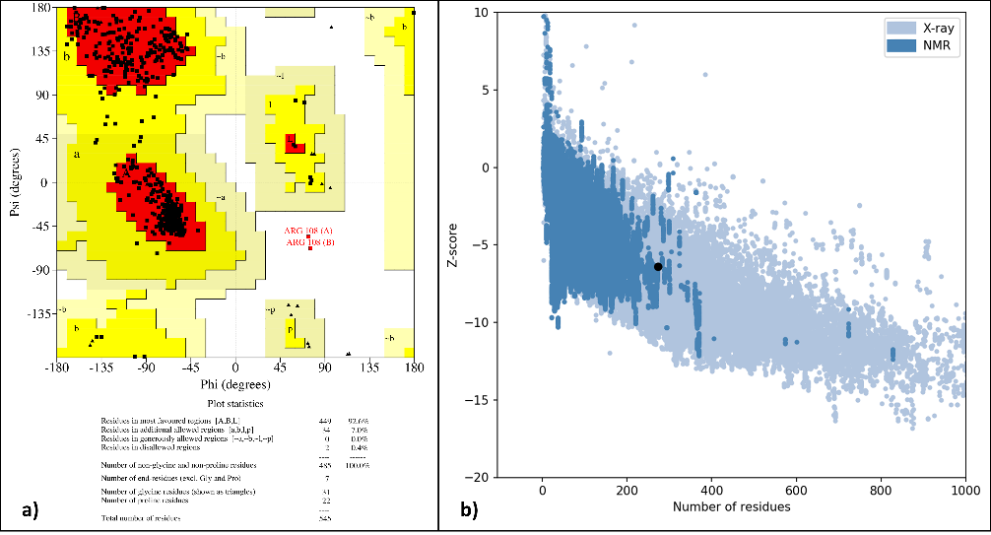

**Figure 3. a)** Ramachandran plot of the target protein (PDB: 4WNP) showing 86.6% residues in the favored region, **b)** Plot showing the z-scores.

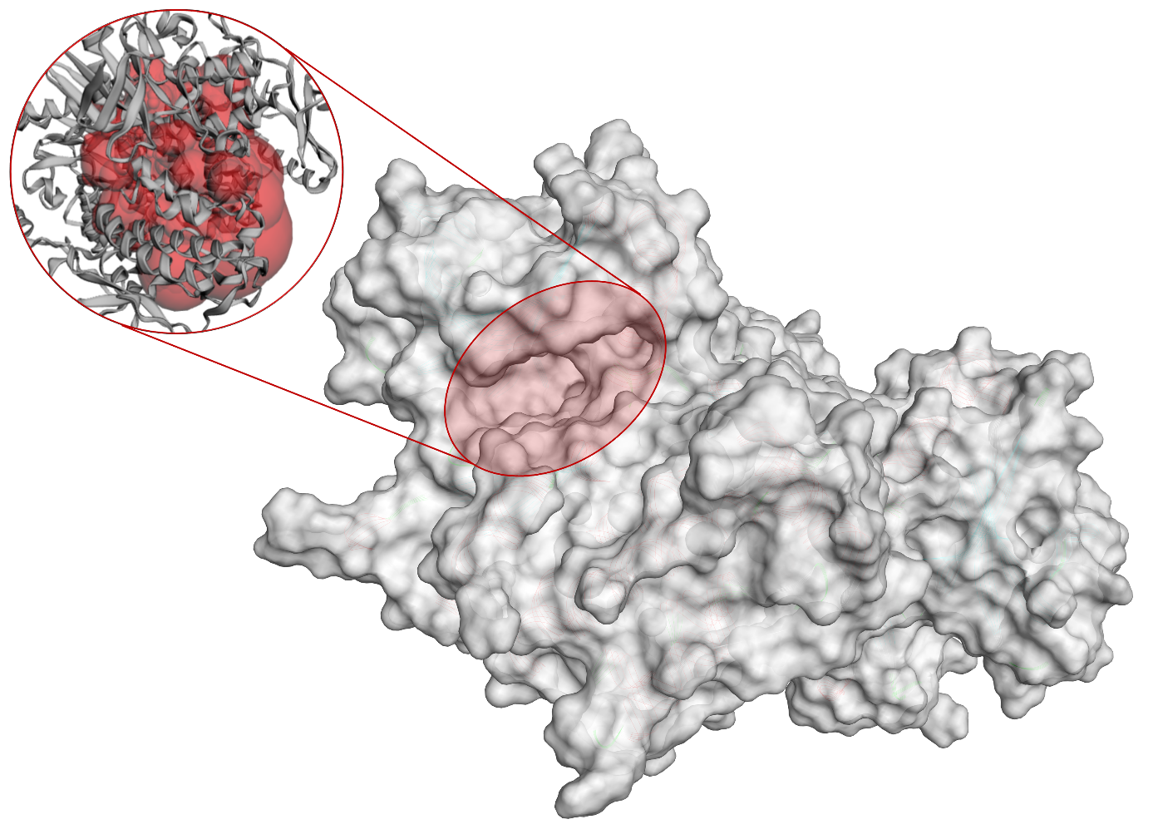

**Figure 4**. Binding pocket (red) of 4WNP observed from CASTp server.

* 1. **Molecular docking**

A molecular docking study was performed to determine the binding energies and best binding confirmations using designed compounds with ULK1 (PDB: 4WNP). AutoDock Vina package of PyRx 0.8 software was used to carry out the molecular docking study. Ligand library of 46 compounds containing designed compounds, five standard molecules from literature and naturally attached ligand in protein structure were docked against ULK1 (PDB: 4WNP). 3RJ (PubChem CID: 86346643) is a naturally attached ligand in protein structure that was used as one of the standards to compare the docking results of designed compounds. **Table 2** represents the binding affinity of compounds present in the prepared ligand library against ULK1 (PDB: 4WNP). The binding affinity of all docked complexes ranged from -8 to -11.3 kcal/mol, respectively. As per molecular docking results, it was observed that 3RJ (PubChem CID: 86346643) showed binding affinity of -10.7 kcal/mol and 1d, 2d, 3b, 3d, 4d, 4e, 5c, 7a, from designed compounds showed the binding affinity equivalent to or more than the binding affinity of 3RJ. It means that designed compounds have a higher binding potential than naturally bound ligand. Five standard molecules selected from the literature were showed binding affinity between -8.9 to -9.3 kcal/mol, which is less than the 3RJ. All the docked molecules were further subjected to determine the interacting residues and type of interaction occurred between all compounds and ULK1 (PDB: 4WNP). **Table 2** represents the hydrophobic interactions, hydrogen bonds, and distance between designed compounds and ULK1. The BIOVIA Discovery Studio Visualizer was used to determine detailed 2D and 3D interactions. 3RJ showed interactions with PHE273, ILE135, HIS130, PHE269, LEU129, SER131, ILE134, HIS130, GLY133, GLY200, LEU172, ASP199, SER174, GLY,133 GLN173, LEU172, GLN173, LYS132, SER174, SER131 amino acid residues of ULK1 (PDB: 4WNP). 2d showed a binding affinity of -11.3 kcal/mol, which is a higher binding affinity as compared to all standard and designed compounds and HIS24, PHE27, LEW59, ILE46, ASN148, PRO149, GLU42, GLY25, TYR94, ALA28, CYS95 are the interacting amino acid residues between 2d and ULK1 (PDB: 4WNP). Extending to that 4e and 4d also showed a good binding affinity with -11.2 and -11.0 kcal/mol. The first three protein-ligand complexes having good binding affinity were used for further molecular dynamic study over the 100 ns of simulation time. **Figure 5** depicts 2D and 3D visualizations of interactions between top-ranked protein-ligand complexes.

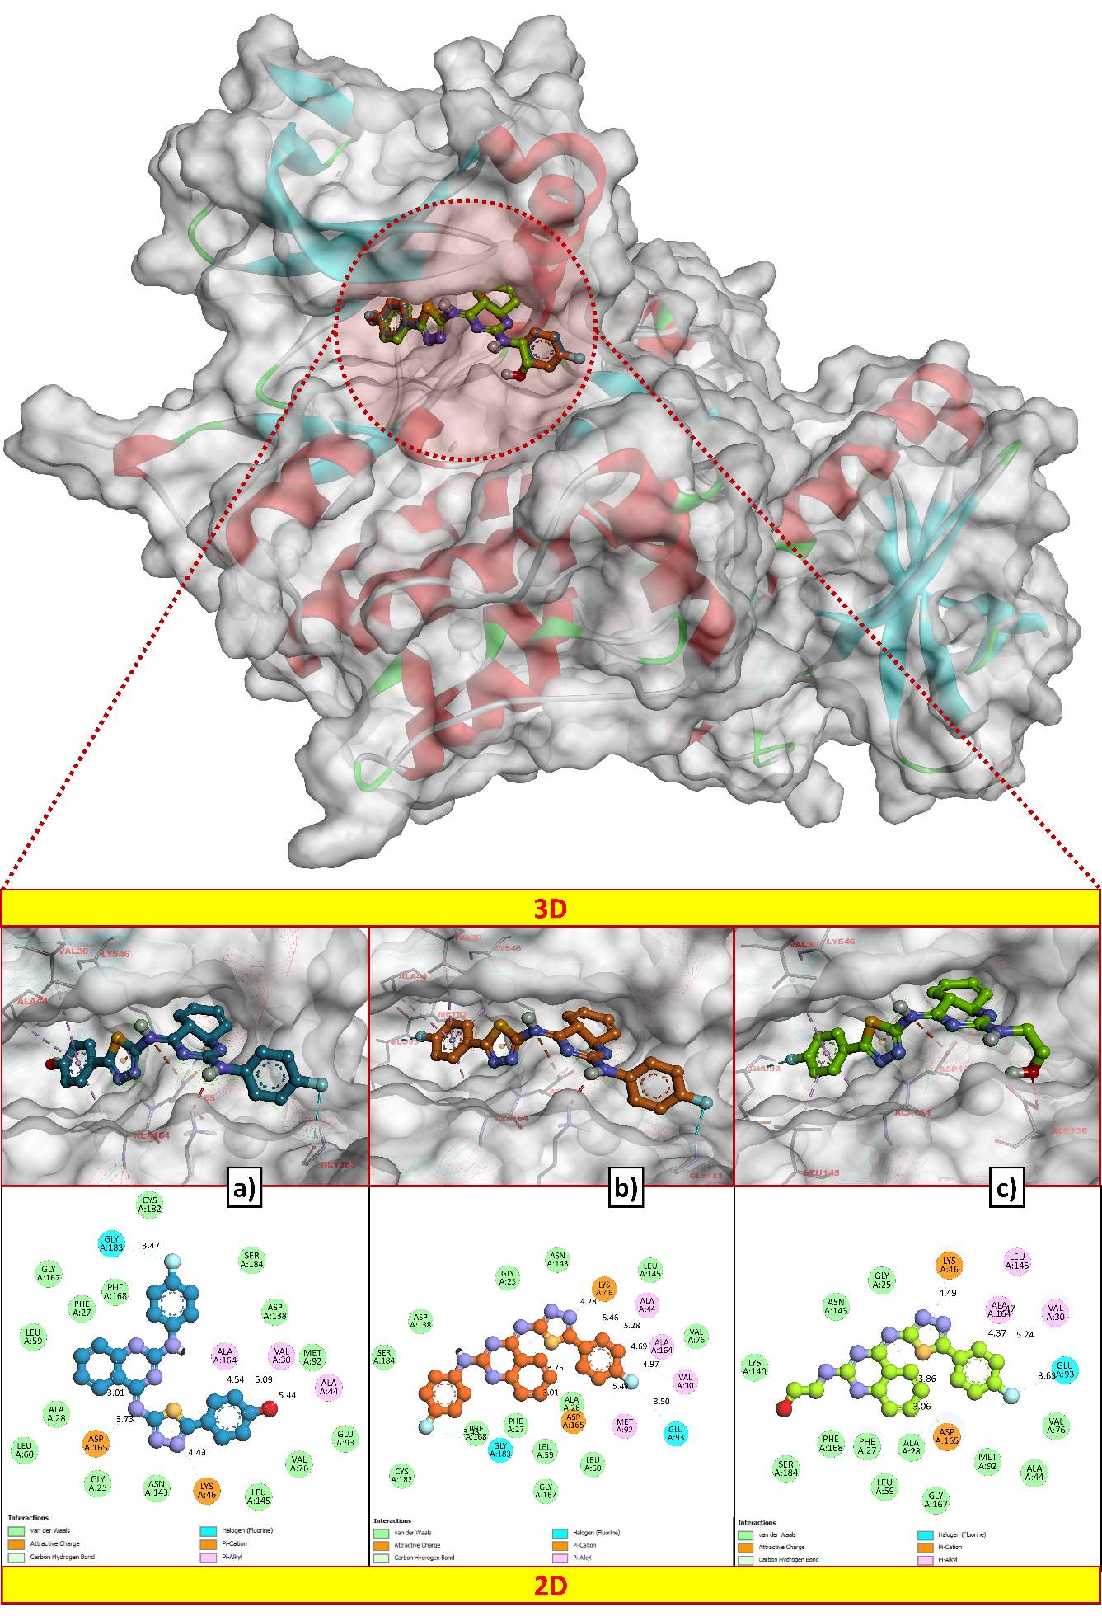

**Figure 5.** 2D and 3D interactions of protein-ligand complexes having good binding affinity. a) 2d ligand (-11.3 kcal/mol), b) 4d ligand (-11.0 kcal/mol), and c) 4e (11.2 kcal/mol).

**Table 2:** Binding energy, hydrophobic interactions, hydrogen and hydrogen bond distance of a ULK and the designed compounds.

|  |  |  |  |  |
| --- | --- | --- | --- | --- |
| **Compound ID** | **Binding**  **Energy**  **(kcal/mol)** | **Hydrophobic Interactions** | **Hydrogen Bonds** | **Hydrogen Bond Distance (Å)** |
| **1a** | -10.3 | ASP102, GLY23, LYS140, ILE22, ASP143, ALA164, VAL176, MET92. | LYS46, HIS24 | 2.99 and 3.30 |
| **1b** | -10.2 | LEU145, VAL176, ASP99, GLY23, HIS24, LYS46, ASP146, PHE168 | - | - |
| **1c** | -10.4 | LEU59, ALA28, PHE27, GLY167 LYS46, GLN142, LYS46, ASN143, ASP165, CYS95, VAL130, GLU93 LYS46, LEW145 | LYS64 | 3.12 |
| **1d** | -10.9 | PHE168, ALA28, LEW59, LYS46, GLU143, LYS46, ASP165, GLU165, GLN142, LEU145, VAL130. | - | - |
| **1e** | -9.5 | ALA28, PHE168, ASP165, LEU59, GLU160 LYS46, LEU60, MET92, VAL130, ALA44 | - | - |
| **2a** | -10 | LEU59, ALA28, PHE27, GLY167 LYS46, GLN142, ASN143, ASP165, CYS95, VAL130, GLU93, LYS46, LEU145 | CYS95 | 2.88 |
| **2b** | -10.4 | TYR79, ARG255, LEU246, ALA249, PHE70, GLY151, LEU246, GLU73, GLN142, LYS162, ASN143, ASP165, LYS162, VAL130, GLU93, LEU246, PRO250 | SER147, GLU271 | 2.83, 3.29, 3.13 and 3.18 |
| **2c** | -9.8 | GLU73, TYR79, LEU256, LYS256, TYR94, LEW41, ARG160, GLN253, GLY42, ASN96, PRO149 | - | - |
| **2d** | -11.3 | GLY167, PHE27, LEU59, ALA28, LEU60, ASP165, GLY25, ASN143, LYS46, LEU145, LEU145, VAL76, GLU93, ALA44, MET92, VAL30, ALA164, ASP138, SER184, CYS182, GLY183, PHE168 | - | - |
| **2e** | -9.6 | GLN253, ARG160, TYR94, SER147, GLU73, ASN148, PRO149, GLU42, GLY271 | LYS162, ASN96 | 3.02 and 3.03 |
| **3a** | -9.1 | VAL176, LEU145, GLY98, TYR94, ILE22, VAL130, MET92, ASP165, HIS24, ALA28, LYS46 | ASN143 | 3.17 |
| **3b** | -10.7 | LEW59, PHE169, ALA26, LEU60, LYS146, VAL130, ILE22 | - | - |
| **3c** | -9.2 | PHE168, GLY25, LYS46, LEW59, ALA28, GLY167, VAL130, ILE22, ALA44 | - | - |
| **3d** | -10.8 | LYS140, GLY183, ASP138, PHE168, LEW59, ALA28, ASP165, LEW60, VAL130, ILE22 | - | - |
| **3e** | -10 | LEU59, PHE168, ALA28, ASP165, VAL130, LEW145, ALA164 | LYS140, LYS146 | 2.98 and 3.01 |
| **4a** | -10.5 | ILE22, VAL130, LEU145, ASP120, HIS24, LYS146, GLY25, ALA28, ASP165, GLN142 | ASP99 | 3.28 |
| **4b** | -9.7 | PHE168, ALA28, HIS24, ASP165, LEU145, GLN142, GLY25, | ASN143 | 3.22 |
| **4c** | -10 | PHE168, LEU59, ASP165, HIS24, ALA164, GLU93, LEU145, VAL167, | LYS64, ASN143 | 3.23 and 2.98 |
| **4d** | -11 | SER184, ASP138, GLY25, ASN143, LYS46, LEU145, ALA44, ALA164, VAL76, VAL30, GLU93, MET92, LEU60, ALA28, ASP165, LEU59, GLY167, LEU59, PHE27, GLY183, PHE168, CYS182 | - | - |
| **4e** | -11.2 | LYS140, SER184, PHE168, PHE27, ALA28, LEU59, GLY167, ASP165, MET92, ALA44, VAL76, GLU93, VAL30, ALA164, LEU145, LYS46, GLY25, ASN143 | - | - |
| **5a** | -10.6 | GLN142, PHE168, ALA28, PHE27, ASP165, ALA164, LEU59, VAL130, GLU93 | LYS46 | 2.98 |
| **5b** | -10.6 | LYS140, PHE27, LEU59, VAL130. ALA164, VAL176, ASP165, LEU145, GLU93 | - | - |
| **5c** | -10.7 | GLY25, ASP165, LYS14, GLU142, VAL130, LEU145, ILE22, ALA44, CYS95, VAL130 | - | - |
| **5d** | -9.7 | PHE168, ASP165, LEU59, ALA28, VAL130, ALA164, LEU145, ASP146 | LYS140, LYS46 | 3.20 and 3.25 |
| **5e** | -8.3 | PHE27, ALA126, ASP165, LYS140, VAL130, GLY98, ASP99, ILE22. CYS95 | ASN143, GLN142, TYR94 | 3.18, 3.29 and 2.78 |
| **6a** | -9.5 | PHE168, ASP165, ALA28, GLY25, GLU142, VAL130, LYS46, ALA44, MET92 | - | - |
| **6b** | -9.2 | LEU60, GLY167, LYS46, HIS24, ALA28, ASP165, VAL130, ALA44, TYR94 | - | - |
| **6c** | -9.3 | PHE27, LY46, ALA28, GLY25, HIS24, LEU59, ALA44, VAL130 | - | - |
| **6d** | 8.3 | LEU59, ALA28, LEU60, ASP165, GLY25, HIS24, LYS46, ILE22 | GLU163 | 2.91 |
| **6e** | -10.3 | LYS46, VAL130, GS24, PHE27, GLY183, PHE168, ASP165, LY25, LEU60, HIS24, CYS182 | - | - |
| **7a** | -10.7 | ASP138, GLU59, ALA28, VAL13 LYS140, PHE168, ASP165 | SER184 | 3.24 |
| **7b** | -9.6 | LEU59, PHE168, LYS46, GLN142, VAL130, ALA28 | - | - |
| **7c** | -10.4 | LYS162, ALA28, LEU41, GLN253, ASP40, GLY151, ARG152, PRO276 | SER147, GLU142 | 3.32 and 3.04 |
| **7d** | -9.7 | PHE27, ALA28, ASP146, LEU59, VAL130, ALA164 | LYS140, LYS46 | 2.97 and 3.10 |
| **7e** | -8.9 | ALA26, GLN142, PHE27, HIS24, ASN143, GLY25, ASP146, VAL130, LEU145, LYS46 | - | - |
| **8a** | -9.0 | LYS46, ALA44, VAL176, GLN93, GLY25, CYS95, ILE22, GLY9 | TYR94 | 2.81 |
| **8b** | -8.9 | LEU172, ASP199, PHE268, SER174, HIS130, GLY133, HIS274 | ARG127, ASP270 | 3.25 and 3.06 |
| **8c** | -9.2 | ALA26, GLY25, HIS24, PHE168, ASN143, LEU59, LYS46, ALA44, ASP165, MET92, VAL130 | - | - |
| **8d** | -8.3 | ALA28, PHE168, GLN142, LYS140, GLY23, ILE22, ALA44, ASP165, TYR94 | ASN143, CYS95 | 3.17 and 3.16 |
| **8e** | -8.0 | GLY25, HIS24, PHE168, ASN143, LEU59, LYS46, ALA44, ASP165, MET92, VAL130 |  |  |
| **STD1** | -9.3 | ALA26, GLY25, HIS24, PHE168, ASN143, LEU59, LYS46, ALA44, ASP165, MET92, VAL130 | GLU95, CYS92 | 2.91 and 2.92 |
| **STD2** | -8.9 | LEU172, ASP199, PHE268, SER174, HIS130, GLY133, HIS274 | - | - |
| **STD3** | -9.0 | PHE168, ASP165, ALA28, GLY25, GLU142, VAL130, LYS46, ALA44, MET92 | - | - |
| **STD4** | -9.0 | LEU172, ASP199, PHE268, SER174, HIS130, GLY133, HIS274 | - | - |
| **STD5** | -9.0 | ASP165, ALA28, GLY25, GLU142, VAL130, LYS46, ALA44, MET92 | - | - |
| **3RJ (PubChem CID: 86346643)** | -10.7 | PHE273, ILE135, HIS130, PHE269, LEU129, SER131, ILE134, HIS130, GLY133, GLY200, LEU172, ASP199, SER174, GLY,133 GLN173, LEU172, GLN173, LYS132, SER174 | SER131 | 2.33 |

* 1. **Pharmacophore analysis**

Pharmacophore modelling was done using PharmaGist server to generate the scored sets of pharmacophoric features. All designed compounds aligned together with the pivot molecule. The best pharmacophore model was selected based on pharmacophoric features showing high score, and to the multiple alignments of designed compounds. PharmaGist algorithm applies standard weighted properties for each pharmacophore feature. The quantitative characteristics of the best-scored pharmacophore model are shown in **Table 3.** Thespatial coordinates for pharmacophore models, obtained from ZincPharmer are shown in **Table 4**. The highest ranked pharmacophore model with a score of 97.500 was selected for spatial feature analysis. A total of 10 features were obtained from which 3 aromatic rings, 3 Hydrogen donors, and 4 Hydrogen acceptors were observed as pharmacophoric features. Geometric characterization of the highest scored pharmacophore model is represented in (**Figure 6)**.

**Table 3**. Generated pharmacophore models from PharmaGist Tool.

|  |  |  |  |  |  |  |
| --- | --- | --- | --- | --- | --- | --- |
| **Pharmacophore model** | **Score of the pharmacophore model** | **Spatial features** | **Aromatic ring** | **Hydrophobic** | **Hydrogen donor** | **Hydrogen acceptor** |
| 1 | 97.500 | 10 | 3 | 0 | 3 | 4 |
| 2 | 97 | 11 | 3 | 1 | 3 | 4 |
| 3 | 90 | 9 | 3 | 0 | 2 | 4 |
| 4 | 82.500 | 9 | 2 | 0 | 3 | 4 |
| 5 | 82.500 | 8 | 3 | 0 | 2 | 3 |
| 6 | 80.777 | 7 | 3 | 0 | 1 | 3 |
| 7 | 75 | 8 | 2 | 0 | 3 | 3 |
| 8 | 75 | 8 | 2 | 0 | 2 | 4 |
| 9 | 75 | 8 | 2 | 0 | 2 | 4 |
| 10 | 74.954 | 9 | 2 | 1 | 3 | 3 |

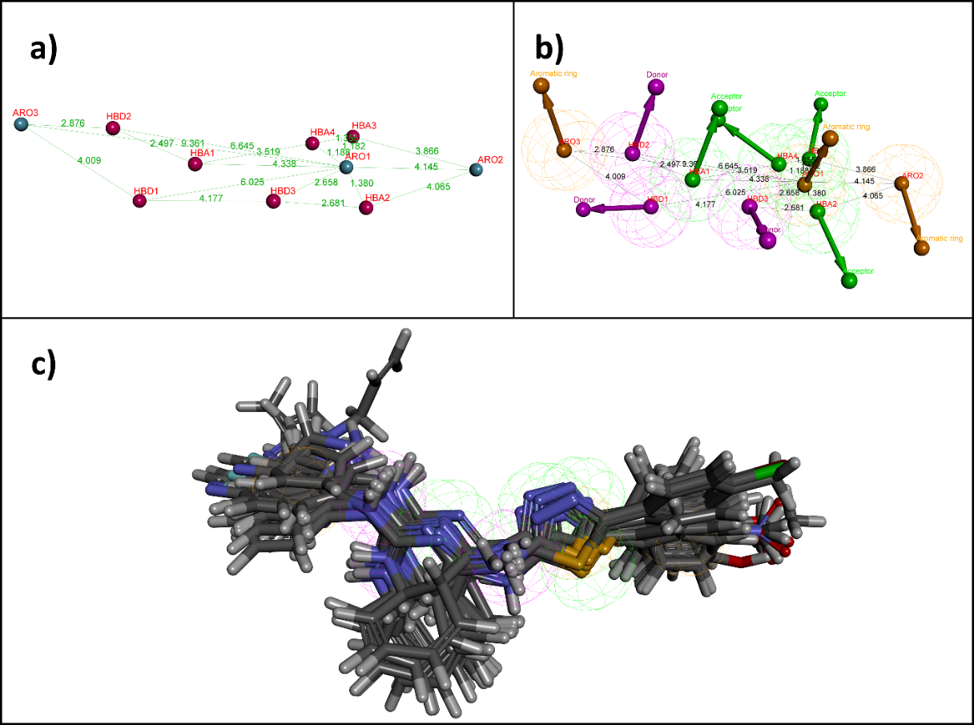

**Figure 6.** Characteristics of the best pharmacophore model having best score. (a) Geometric distance. (b) Pharmacophoric features. (c) Aligned molecules

**Table 4.** Pharmacophoric features and spatial coordinates for pharmacophore Models obtained from Pharmagist and ZincPharmer.

|  |  |  |  |  |
| --- | --- | --- | --- | --- |
| **Pharmacophoric features** | **Spatial coordinates** | | | |
| **X** | **Y** | **Z** | **Radius** |
| HBA1 | 109.68 | 50.39 | 19.12 | 0.50 |
| HBA2 | 105.57 | 48.02 | 16.66 | 0.50 |
| HBA3 | 107.25 | 46.31 | 17.16 | 0.50 |
| HBA4 | 107.69 | 47.45 | 17.75 | 0.50 |
| HBD1 | 110.68 | 51.75 | 18.09 | 0.50 |
| HBD2 | 111.09 | 51.15 | 20.34 | 0.50 |
| HBD3 | 106.98 | 49.82 | 18.07 | 0.50 |
| ARO1 | 106.68 | 47.35 | 17.13 | 1.10 |
| ARO2 | 104.59 | 44.40 | 15.10 | 1.10 |
| ARO3 | 113.56 | 52.56 | 20.76 | 1.10 |

* 1. **Drug-likeness and *in-silico* ADMET prediction**

Drug-likeness and *in-silico* ADMET studies were performed to determine the drug-like candidates from designed compounds. Prediction of drug-likeness of designed compounds was done based on Lipinski’s rule of five, Veber's rule, Ghose’s rule, Egan's rule, and Muegge's rule, which are commonly used methods to determine the drug-like properties of compounds. All the designed compounds followed Lipinski’s rule of five with minimum or zero violation in rule except 8a does not follow Lipinski’s criteria. Therefore, designed compounds are present within an acceptable range of drug-likeness properties with minimum violations in Lipinski’s rule of five as shown in **Table 5**.

**Table 5.** Lipinski’s rule of five and Drug-likeness prediction of designed compounds.

|  |  |  |  |  |  |  |  |  |  |  |  |
| --- | --- | --- | --- | --- | --- | --- | --- | --- | --- | --- | --- |
| **Compound** | **Lipinski’s rule of five** | | | | | **Lipinski’s violations** | **Drug likeness** | | | | |
| **MW** | **mLogP** | **nHBA** | **nHBD** | **MR** | **Lipinski** | **Veber** | **Ghose** | **Egan** | **Muegge** |
| 1a | 478.57 | 3.41 | 5 | 2 | 149.67 | 0 | Yes | Yes | No | Yes | Yes |
| 1b | 413.5 | 3.16 | 4 | 3 | 130.38 | 0 | Yes | Yes | No | Yes | Yes |
| 1c | 400.46 | 2.07 | 6 | 2 | 121.56 | 0 | Yes | Yes | Yes | Yes | Yes |
| 1d | 416.47 | 4.07 | 5 | 2 | 125.93 | 0 | Yes | Yes | Yes | Yes | Yes |
| 1e | 366.44 | 1.94 | 5 | 3 | 110.72 | 0 | Yes | Yes | Yes | Yes | Yes |
| 2a | 494.57 | 2.9 | 6 | 3 | 151.69 | 0 | Yes | No | No | No | Yes |
| 2b | 429.5 | 2.64 | 5 | 4 | 132.4 | 0 | Yes | No | No | No | Yes |
| 2c | 416.46 | 1.97 | 7 | 3 | 123.59 | 0 | Yes | No | Yes | No | Yes |
| 2d | 432.47 | 3.54 | 6 | 3 | 127.95 | 0 | Yes | Yes | Yes | Yes | Yes |
| 2e | 382.44 | 1.83 | 6 | 4 | 112.75 | 0 | Yes | No | Yes | No | Yes |
| 3a | 513.02 | 3.88 | 5 | 2 | 154.68 | 1 | Yes | Yes | No | Yes | Yes |
| 3b | 447.94 | 3.65 | 4 | 3 | 135.39 | 0 | Yes | Yes | No | Yes | Yes |
| 3c | 434.9 | 2.97 | 6 | 2 | 126.57 | 0 | Yes | Yes | Yes | Yes | Yes |
| 3d | 450.92 | 4.55 | 5 | 2 | 130.94 | 1 | Yes | Yes | No | Yes | Yes |
| 3e | 400.89 | 2.85 | 5 | 3 | 115.73 | 0 | Yes | Yes | Yes | Yes | Yes |
| 4a | 496.56 | 3.78 | 6 | 2 | 149.62 | 0 | Yes | Yes | No | Yes | Yes |
| 4b | 431.49 | 3.54 | 5 | 3 | 130.33 | 0 | Yes | Yes | No | Yes | Yes |
| 4c | 418.45 | 2.86 | 7 | 2 | 121.52 | 0 | Yes | Yes | Yes | Yes | Yes |
| 4d | 434.46 | 4.45 | 6 | 2 | 125.89 | 1 | Yes | Yes | Yes | Yes | Yes |
| 4e | 384.43 | 2.73 | 6 | 3 | 110.68 | 0 | Yes | Yes | Yes | Yes | Yes |
| 5a | 478.57 | 3.41 | 5 | 2 | 149.67 | 0 | Yes | Yes | No | Yes | Yes |
| 5b | 427.52 | 3.38 | 4 | 3 | 135.34 | 0 | Yes | Yes | No | Yes | Yes |
| 5c | 414.49 | 2.7 | 6 | 2 | 126.53 | 0 | Yes | Yes | Yes | Yes | Yes |
| 5d | 430.5 | 4.28 | 5 | 2 | 130.9 | 1 | Yes | Yes | No | Yes | Yes |
| 5e | 380.47 | 2.58 | 5 | 3 | 115.69 | 0 | Yes | Yes | Yes | Yes | Yes |
| 6a | 508.6 | 3.11 | 6 | 2 | 156.16 | 1 | Yes | Yes | No | Yes | Yes |
| 6b | 427.52 | 3.38 | 4 | 3 | 135.34 | 0 | Yes | Yes | No | Yes | Yes |
| 6c | 430.49 | 2.19 | 7 | 2 | 128.05 | 0 | Yes | Yes | Yes | No | Yes |
| 6d | 446.5 | 3.75 | 6 | 2 | 132.42 | 0 | Yes | Yes | No | Yes | Yes |
| 6e | 396.47 | 2.06 | 6 | 3 | 117.22 | 0 | Yes | Yes | Yes | No | Yes |
| 7a | 557.47 | 3.98 | 5 | 2 | 157.37 | 1 | Yes | Yes | No | Yes | Yes |
| 7b | 492.39 | 3.75 | 4 | 3 | 138.08 | 0 | Yes | Yes | No | Yes | Yes |
| 7c | 479.36 | 3.08 | 6 | 2 | 129.26 | 0 | Yes | Yes | Yes | Yes | Yes |
| 7d | 495.37 | 4.66 | 5 | 2 | 133.63 | 1 | Yes | Yes | No | Yes | Yes |
| 7e | 445.34 | 2.96 | 5 | 3 | 118.42 | 0 | Yes | Yes | Yes | Yes | Yes |
| 8a | 523.57 | 4.08 | 7 | 2 | 158.49 | 2 | No | No | No | No | No |
| 8b | 458.5 | 3.53 | 6 | 3 | 139.2 | 0 | Yes | No | No | No | No |
| 8c | 445.46 | 2.47 | 8 | 2 | 130.38 | 1 | Yes | No | No | No | No |
| 8d | 461.47 | 4.41 | 7 | 2 | 134.75 | 1 | Yes | No | No | No | Yes |
| 8e | 411.44 | 2.31 | 7 | 3 | 119.55 | 0 | Yes | No | Yes | No | No |

Pharmacokinetics of designed compounds (Absorption, Distribution, Metabolism, Excretion, and Toxicity) was characterized virtually with the help of pkCSM servers to determine the ADMET profile of designed compounds. The results of ADMET prediction showed that designed compounds showed good ADME properties, as shown in **Table 6**. Some of them showed positive results in AMES toxicity, and hence they may be mutagenic. *In silico* ADMET profile of the designed compounds was observed with satisfactory results.

**Table 6.** Predicted *In silico* ADMET properties for designed compounds**.**

|  |  |  |  |  |  |  |  |  |  |  |  |  |  |
| --- | --- | --- | --- | --- | --- | --- | --- | --- | --- | --- | --- | --- | --- |
| **Compound** | **Absorption** | **Distribution** | | | **Metabolism** | | | | | | | **Excretion** | **Toxicity** |
| **Intestinal absorption (human)** | **VDss (human)** | **BBB permeability** | **CNS permeability** | **Substrate** | | **Inhibitors** | | | | | **Total clearance** | **AMES toxicity** |
| **CYP** | | | | | | |
| **2D6** | **3A4** | **1A2** | **2C19** | **2C9** | **2D6** | **3A4** |
| **Numeric (%absorbed)** | **Numeric (log L kg-1)** | **Numeric (log BB)** | **Numeric (log PS)** | **Categorical (Yes/No)** | | | | | | | **Numeric (log mL min -1 kg -1)** | **Categorical (Yes/No)** |
| 1a | 100 | 0.214 | -0.467 | -1.969 | No | Yes | No | Yes | Yes | No | No | 0.178 | No |
| 1b | 92.864 | 0.57 | -0.646 | -1.958 | No | Yes | No | Yes | Yes | No | No | 0.099 | Yes |
| 1c | 97.126 | 0.846 | -1.04 | -3.371 | No | No | Yes | No | Yes | No | Yes | -0.11 | Yes |
| 1d | 81.013 | 0.641 | -0.287 | -1.824 | No | Yes | Yes | Yes | Yes | No | No | -0.105 | No |
| 1e | 82.763 | 0.872 | -0.943 | -2.678 | No | Yes | No | No | No | No | No | 0.094 | No |
| 2a | 100 | 0.173 | -1.035 | -2.149 | No | Yes | No | Yes | Yes | No | Yes | 0.238 | No |
| 2b | 92.916 | 0.639 | -0.842 | -2.139 | No | Yes | No | Yes | Yes | No | Yes | 0.158 | Yes |
| 2c | 86.648 | 0.75 | -1.328 | -2.475 | No | No | No | No | Yes | No | Yes | -0.06 | No |
| 2d | 100 | 0.702 | -0.994 | -2.005 | No | Yes | No | Yes | Yes | No | Yes | -0.045 | No |
| 2e | 75.829 | 0.985 | -1.142 | -2.802 | No | No | No | No | No | No | No | 0.175 | No |
| 3a | 100 | 0.201 | -0.654 | -1.856 | No | Yes | Yes | Yes | Yes | No | No | 0.169 | No |
| 3b | 93.917 | 0.559 | -0.828 | -1.845 | No | Yes | No | Yes | Yes | No | No | 0.09 | Yes |
| 3c | 94.111 | 0.82 | -1.281 | -2.171 | No | No | No | No | Yes | No | Yes | -0.107 | Yes |
| 3d | 80.194 | 0.636 | -0.474 | -1.712 | No | Yes | No | Yes | Yes | No | No | -0.114 | No |
| 3e | 83.292 | 1.09 | -1.128 | -2.497 | No | No | No | No | No | No | No | 0.128 | No |
| 4a | 100 | 0.162 | -0.687 | -2.011 | No | Yes | No | Yes | Yes | No | Yes | 0.179 | No |
| 4b | 99.163 | 0.378 | -0.867 | -2 | No | Yes | No | Yes | Yes | No | Yes | 0.1 | Yes |
| 4c | 93.215 | 0.745 | -1.314 | -2.324 | No | No | No | No | No | No | Yes | -0.099 | No |
| 4d | 81.401 | 0.438 | -0.507 | -1.867 | No | Yes | No | Yes | Yes | No | Yes | -0.104 | No |
| 4e | 82.396 | 0.992 | -1.167 | -2.651 | No | No | No | No | No | No | No | 0.137 | No |
| 5a | 100 | 0.214 | -0.467 | -1.969 | No | Yes | No | Yes | Yes | No | No | 0.178 | No |
| 5b | 93.209 | 0.582 | -0.675 | -1.886 | No | Yes | No | Yes | Yes | No | No | 0.102 | Yes |
| 5c | 93.403 | 0.856 | -1.106 | -2.211 | No | No | No | No | No | No | Yes | -0.095 | Yes |
| 5d | 81.652 | 0.661 | -0.299 | -1.752 | No | Yes | Yes | Yes | Yes | No | No | -0.101 | No |
| 5e | 82.584 | 1.132 | -0.975 | -2.538 | No | No | No | No | No | No | No | 0.141 | No |
| 6a | 100 | 0.143 | -0.714 | -2.134 | No | Yes | No | Yes | Yes | No | Yes | 0.25 | No |
| 6b | 93.209 | 0.582 | -0.675 | -1.886 | No | Yes | No | Yes | Yes | No | No | 0.102 | Yes |
| 6c | 94.675 | 0.72 | -1.341 | -2.527 | No | No | No | No | No | No | Yes | -0.029 | No |
| 6d | 82.807 | 0.433 | -0.534 | -1.989 | No | Yes | No | Yes | Yes | No | Yes | -0.033 | No |
| 6e | 83.856 | 0.974 | -1.163 | -2.853 | No | No | No | No | No | No | No | 0.207 | No |
| 7a | 100 | 0.201 | -0.662 | -1.834 | No | Yes | Yes | Yes | Yes | No | No | 0.15 | No |
| 7b | 93.653 | 0.561 | -0.849 | -1.823 | No | Yes | No | Yes | Yes | No | No | 0.07 | Yes |
| 7c | 93.847 | 0.829 | -1.29 | -2.148 | No | No | No | No | Yes | No | Yes | -0.127 | Yes |
| 7d | 80.127 | 0.638 | -0.482 | -1.689 | No | Yes | No | Yes | Yes | No | No | -0.133 | No |
| 7e | 83.028 | 1.099 | -1.149 | -2.474 | No | No | No | No | No | No | No | 0.109 | No |
| 8a | 99.201 | 0.379 | -0.578 | -2.071 | No | Yes | No | Yes | Yes | No | Yes | 0.051 | Yes |
| 8b | 89.752 | 1.48 | -1.055 | -2.061 | No | Yes | No | Yes | No | Yes | Yes | -0.02 | Yes |
| 8c | 89.809 | 0.651 | -1.635 | -2.499 | No | No | No | No | No | No | Yes | -0.289 | Yes |
| 8d | 97.399 | 1.178 | -0.656 | -1.953 | No | Yes | No | No | No | Yes | Yes | -0.212 | Yes |
| 8e | 78.989 | 0.877 | -1.186 | -2.825 | No | Yes | No | No | No | No | No | -0.055 | No |

* 1. **Bioactivity score**

The bioactivity score was calculated for the GPCR ligand, ion channel modulator, kinase inhibitor, nuclear receptor ligand, protease inhibitor, and enzyme inhibitor. An organic molecule with a probability of bioactivity score greater than 0.00 is active, (-0.50 to 0.0) is moderately active, and less than -0.50 is inactive. In our study, all the proposed ligands were subjected to the bioactivity score presented in **Table 7**. Comparing the bioactivity score of STD molecule and proposed ligand have similar scores, especially in the case of enzyme inhibition.

**Table 7.** Bioactivity score of the ligand (1a-e to 8a-e)

|  |  |  |  |  |  |  |
| --- | --- | --- | --- | --- | --- | --- |
| **Ligand No.** | **GPCR ligand** | **Ion channel modulator** | **Kinase inhibitor** | **Nuclear receptor ligand** | **Protease inhibitor** | **Enzyme inhibitor** |
| **1a** | -0.09 | -0.38 | -0.07 | -0.40 | -0.20 | 0.03 |
| **1b** | -0.10 | -0.46 | -0.02 | -0.44 | -0.11 | 0.14 |
| **1c** | -0.07 | -0.55 | -0.02 | -0.38 | -0.27 | 0.03 |
| **1d** | -0.09 | -0.47 | -0.07 | -0.36 | -0.16 | -0.00 |
| **1e** | 0.04 | -0.43 | -0.00 | -0.32 | 0.01 | 0.17 |
| **2a** | -0.06 | -0.36 | -0.04 | -.29 | -0.19 | 0.06 |
| **2b** | -0.06 | -0.41 | 0.01 | -0.32 | -0.10 | 0.17 |
| **2c** | -0.03 | -0.50 | 0.01 | -0.25 | -0.25 | 0.07 |
| **2d** | **-0.06** | **-0.42** | **-0.04** | **-0.23** | **-0.15** | **0.04** |
| **2e** | 0.07 | -0.39 | 0.03 | -0.20 | -0.00 | 0.19 |
| **3a** | -0.09 | -0.40 | -0.08 | -0.40 | -0.23 | 0.00 |
| **3b** | -0.09 | -0.45 | -0.03 | -0.45 | -0.14 | 0.10 |
| **3c** | -0.07 | -0.54 | -0.04 | -0.38 | -0.30 | 0.00 |
| **3d** | -0.09 | -0.46 | -0.08 | -0.36 | -0.19 | -0.03 |
| **3e** | -0.04 | -0.42 | -0.02 | -0.32 | -0.04 | 0.13 |
| **4a** | -0.09 | -0.40 | -0.04 | -0.37 | -0.22 | 0.01 |
| **4b** | -0.09 | -0.46 | 0.01 | -0.41 | -0.13 | 0.12 |
| **4c** | -0.06 | -0.54 | 0.00 | -0.35 | -0.28 | 0.02 |
| **4d** | **-0.09** | **-0.46** | **-0.07** | **-0.34** | **-0.16** | **0.00** |
| **4e** | **-0.04** | **-0.43** | **0.02** | **-0.28** | **-0.02** | **0.14** |
| **5a** | -0.09 | -0.38 | -0.07 | -0.40 | -0.20 | 0.03 |
| **5b** | -0.13 | -0.51 | -0.06 | -0.45 | -0.15 | 0.08 |
| **5c** | -0.10 | -0.59 | -0.07 | -0.39 | -0.31 | -0.02 |
| **5d** | -0.12 | -0.52 | -0.11 | -0.37 | -0.21 | -0.05 |
| **5e** | -0.00 | -0.49 | -0.05 | -0.33 | -0.05 | 0.10 |
| **6a** | -0.12 | -0.47 | -0.9 | -0.38 | -0.23 | -0.01 |
| **6b** | -0.13 | -0.51 | -0.06 | -0.45 | -0.15 | 0.08 |
| **6c** | -0.10 | -0.58 | -0.06 | -0.37 | -0.30 | -0.01 |
| **6d** | -0.13 | -0.51 | -0.10 | -.35 | -0.20 | -0.04 |
| **7e** | -0.16 | -0.45 | -0.10 | -0.46 | -0.28 | -0.03 |
| **7a** | -0.17 | -0.51 | -0.05 | -0.52 | -0.20 | 0.07 |
| **7b** | -0.15 | -0.59 | -0.06 | -0.46 | -0.36 | -0.03 |
| **7c** | -0.17 | -0.52 | -0.10 | -0.43 | -0.25 | -0.06 |
| **7d** | -0.05 | -0.49 | -0.05 | -0.41 | -0.10 | 0.09 |
| **7e** | -0.04 | -050 | -0.04 | -0.42 | -0.26 | 0.08 |
| **8a** | -0.19 | -0.48 | -0.17 | -0.43 | -0.28 | -0.06 |
| **8b** | -0.20 | -0.46 | -0.13 | -0.47 | -0.20 | 0.04 |
| **8c** | -0.19 | -0.55 | -0.14 | -0.43 | -0.36 | -0.06 |
| **8d** | 0.20 | -0.47 | -0.18 | -0.39 | -0.26 | -0.08 |
| **8e** | -0.11 | -0.44 | -0.13 | -0.37 | -0.13 | 0.05 |
| **STD 1** | **0.44** | **0.24** | **0.69** | **-0.09** | **0.60** | **0.33** |
| **STD 2** | **0.06** | **0.22** | **0.33** | **-0.26** | **-0.14** | **0.13** |
| **STD 3** | **0.27** | **0.07** | **1.06** | **-0.96** | **-0.35** | **0.20** |
| **STD 4** | **0.27** | **-0.11** | **0.05** | **-0.08** | **0.03** | **0.10** |
| **STD 5** | **0.10** | **-0.01** | **0.60** | **-0.26** | **0.07** | **-0.10** |

* 1. **Prediction of Activity Spectra of Substances (PASS)**

The designed compounds were subjected to PASS prediction for probable antineoplastic, and autoimmune disorders treatment activity. For each probable activity, the prediction accuracy was estimated in PASS as the probable pair of active and inactive compounds. Pa is the probability of belonging to the class of “active”, and Pi is the probability of belonging to the class of “inactive”. In pass prediction, the threshold is set to Pa = Pi (or Sensitivity = Specificity) by default. Hence, all activities with Pa > Pi are considered and the data obtained from PASS prediction is tabulated in (**Table 8)**.

**Table 8.** Predicted antineoplastic, and autoimmune disorders treatment activity of compounds using PASS.

|  |  |  |  |  |
| --- | --- | --- | --- | --- |
| **Compound ID** | **Antineoplastic** | | **Autoimmune disorders treatment** | |
| **Pa** | **Pi** | **Pa** | **Pi** |
| 1a | 0.512 | 0.068 | 0.47 | 0.035 |
| 1b | 0.744 | 0.019 | 0.703 | 0.006 |
| 1c | 0.527 | 0.063 | 0.677 | 0.008 |
| 1d | 0.577 | 0.05 | 0.726 | 0.005 |
| 1e | 0.492 | 0.074 | 0.698 | 0.007 |
| 2a | 0.513 | 0.068 | 0.411 | 0.053 |
| 2b | 0.72 | 0.023 | 0.618 | 0.011 |
| 2c | 0.527 | 0.064 | 0.587 | 0.014 |
| 2d | 0.569 | 0.052 | 0.652 | 0.009 |
| 2e | 0.507 | 0.069 | 0.635 | 0.01 |
| 3a | 0.423 | 0.096 | 0.449 | 0.041 |
| 3b | 0.649 | 0.035 | 0.664 | 0.008 |
| 3c | 0.404 | 0.103 | 0.631 | 0.01 |
| 3d | 0.462 | 0.083 | 0.69 | 0.007 |
| 3e | 0.385 | 0.11 | 0.662 | 0.008 |
| 4a | 0.454 | 0.086 | 0.484 | 0.031 |
| 4b | 0.677 | 0.03 | 0.698 | 0.007 |
| 4c | 0.447 | 0.088 | 0.674 | 0.008 |
| 4d | 0.577 | 0.05 | 0.726 | 0.005 |
| 4e | 0.423 | 0.096 | 0.694 | 0.007 |
| 5a | 0.512 | 0.068 | 0.47 | 0.035 |
| 5b | 0.7 | 0.26 | 0.671 | 0.008 |
| 5c | 0.482 | 0.77 | 0.64 | 0.009 |
| 5d | 0.53 | 0.063 | 0.696 | 0.007 |
| 5e | 0.454 | 0.086 | 0.669 | 0.008 |
| 6a | 0.511 | 0.068 | 0.416 | 0.051 |
| 6b | 0.7 | 0.026 | 0.671 | 0.008 |
| 6c | 0.523 | 0.065 | 0.588 | 0.014 |
| 6d | 0.565 | 0.053 | 0.652 | 0.009 |
| 6e | 0.494 | 0.073 | 0.621 | 0.011 |
| 7a | 0.499 | 0.072 | 0.401 | 0.056 |
| 7b | 0.716 | 0.023 | 0.617 | 0.011 |
| 7c | 0.508 | 0.069 | 0.585 | 0.014 |
| 7d | 0.553 | 0.056 | 0.652 | 0.009 |
| 7e | 0.479 | 0.078 | 0.619 | 0.011 |
| 8a | 0.464 | 0.083 | 0.394 | 0.058 |
| 8b | 0.686 | 0.029 | 0.612 | 0.011 |
| 8c | 0.462 | 0.083 | 0.571 | 0.016 |
| 8d | 0.51 | 0.068 | 0.646 | 0.009 |
| 8e | 0.437 | 0.091 | 0.604 | 0.012 |

* 1. **Molecular dynamic simulation**

As per the molecular docking results, **2d, 4d,** and **4e** were identified as hit molecules, showing good binding affinity with the targeted protein structure. According to PASS predictions, 4d showed better results for Pa > Pi than **2d** and **4e**. Therefore, the protein-ligand complex systems of targeted protein (PDB: 4WNP) and **4d** were further subjected to molecular dynamic (MD) simulation studies to investigate the conformational stability of the complex. MD simulation was performed using WebGro to determine the time-dependent motions, behavior, and configurational changes between subjected protein-ligand complexes over 100 ns. CABS-flex ver. 2.0 was used to determine the root mean square fluctuation (RMSF) of complex systems. Analysis of MD trajectories was done using parameters such as root mean square deviation (RMSD), root mean square fluctuation (RMSF), the radius of gyration (*R*g), hydrogen bonds (HBs), and principal component analysis (PCA).

The RMSD values were calculated for all frames present in the MD simulation trajectory of each simulated protein-ligand complex. The average change of atom displacement for the 4WNP-4d complex system over 100 ns MD simulation was estimated using RMSD and the structural stability of the complex system was also investigated. These RMSD profiles of the 4WNP-4d complex help to determine the behavior of the backbone and heavy atoms of the protein. The lower deviations in RMSD values represent the more stable nature of protein and protein-ligand complex. Hence, the stability of subjected 4WNP-4d complex was analyzed with the help of RMSD values. And the calculations were done to obtain the equilibrium time of the simulated complexes. Through the results of the RMSD analysis, it is observed that the simulated complex has minimum deviations in the RMSD. **Figure 7a** represents the RMSD plot for the 4WNP-4d complex. The RMSD values for 4WNP-4d ranged between 0.4 nm to 0.6 nm, respectively According to the RMSD plot for 4WNP-4d, the complex was stable over 100 ns with a minimum deviation.

The RMSF profile was determined for the protein and protein-ligand complexes (**Figure 7b**). It measures the movement of each residue around the average position along the trajectory, revealing the flexibility of a specific protein region during the MD simulation. **Figure 7b** represents the RMSF of the 4WNP-4d complex. It was observed that ALA37 (RMSF value: 0.29 nm), ALA36 (RMSF value: 0.4 nm), HIS39 (RMSF value: 0.38 nm), ASP40 (RMSF value: 0.24 nm), ALA150 (RMSF value: 0.29 nm), GLU151 (RMSF value: 0.26 nm), ARG152 (RMSF value: 0.24 nm), ARG153 (RMSF value: 0.25 nm), ALA154 (RMSF value: 0.27 nm), SER174 (RMSF value: 0.31 nm), ASN175 (RMSF value: 0.47 nm), MET176 (RMSF value: 0.33 nm), ALA179 (RMSF value: 0.41 nm) amino acid residues of 4WNP-4d showed fluctuations in which ASN175, ALA36, ALA179 displayed high fluctuations. However, the RMSF values are lower than the observed RMSD values and remained in the acceptable region, confirming the stability of particular amino acid residues.

*R*g trajectory of MD simulation was computed to assess the overall stability of protein structure duringMD simulation. It was also used to determine the compactness of protein due to the presence or absence of ligands over 100 ns. A higher *R*g value of the protein-ligand complex reflects the less compactness in the complex. If the *R*g displays a value that is largely constant during the MD simulation. Otherwise, it would be viewed as an unfolded structure and can be called a stable folded structure.*R*g values for 4WNP-4d were studied over 100 ns at 300 K. In terms of MD trajectory analysis, the *R*g values for the 4WNP-4d ranged between 2.6 to 2.7 nm indicating no significant changes after 10 ns. It indicates that protein in presence of 4d, did not show any conformational changes. According to the results of computed *R*g, the simulated complex showed conformational stability with minimum fluctuation in the *R*gvalues **(Figure 7c)**. Hydrogen bonds (HBs) play a significant role in stabilizing the protein-ligand complex. In addition, HBs responsible for drug specificity, metabolization, and adsorption in the body. HBs maintain the overall confirmation of the simulated complex. Therefore, MD trajectories were also analyzed to examine the time evaluation of the number of HBs between protein-ligand complexes formed during the 100 ns simulation. The number of HBs present in the 4WNP-4d, complex system with consistent over the 100 ns MD simulation at 300 K **(Figure 7d)**. No significant changes were observed in the hydrogen bond interactions between the 4WNP-4d complex and a maximum of six hydrogen bonds were observed in the initial phase of MD simulation.

Principal component analysis (PCA) of 4WNP-4d was performed using obtained MD trajectory. A PCA helps to determine the variability in subjected MD trajectories by reducing the dimensionality as possible. The collective motions with conformational flexibility of the simulated 4WNP-4d complex at 300K were studied using the PCA tool of the Bio3D package. Dominant motions of the 4WNP-4d complex were extracted and compared for the first three eigenvectors of 4WNP-4d. The colors from blue to white to red of captured variance by eigenvectors represented the time of sampling of the simulated complex. Obtained PCA results for 4WNP-4d complex system showed the PCA variability of 28% in terms of the internal motions of MD trajectory while the PC2 statistics represented the minimal variability with 12.21%, and PC3 indicated 10.44% signifying the binding stability between 4WNP and 4d with good Eigen scores and the computed atomic motion variabilities of 4WNP-4d is represented in **Figure 6a-b**. Moreover, the comparison of active sites of 4WNP and 4d at different time points (0, 25, 50, 75, and 100 ns) of MD trajectory period was done to check the dynamic behavior of the 4WNP-4d complex system during the 100 ns simulation time and the snapshots of complex at 25, 50, 75, and 100 ns are represented in **Supplementary Figure S2**. The interactions of 4WNP-4d observed over 100 ns using MD simulation is represented in **Supplementary Material Video S1**. Based on the overall analysis of MD trajectories, it was observed that the 4WNP-4d complex system showed stable confirmation over the period of 100 ns.

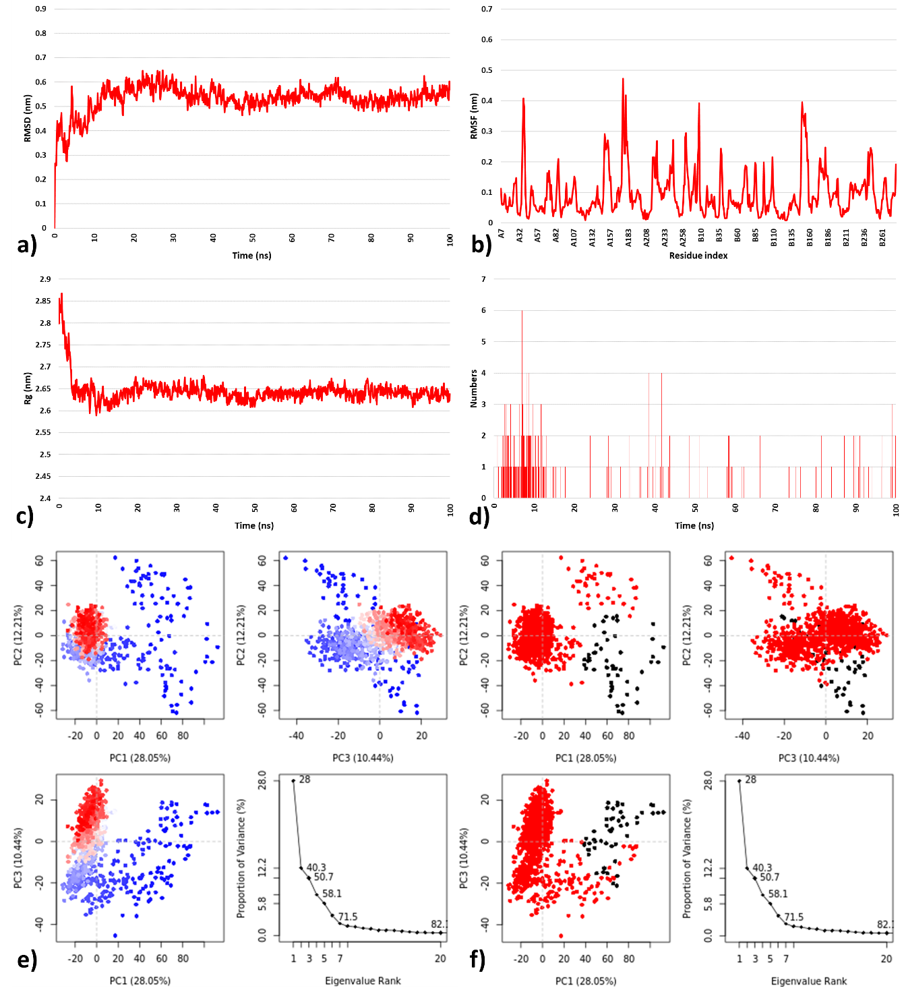

**Figure 7.** **a)** RMSD, **b)** RMSF, **c)** *R*g, and **d)** HBs and **e-f)** PCA for the 4WNP-4d complex system at 300 K for 100 ns.

1. **Conclusion**

The present study aimed to identify novel inhibitors against the ULK enzyme using structure-based pharmacophore modeling, molecular docking, and MD simulation and drug-likeness properties. Molecular docking was performed to investigate possible binding modes of thiadiazole derivatives as anticancer moieties against ULK (PDB: 4WNP). In terms of docking results, it was revealed that hydrogen bond interactions with LYS46, HIS24, ASN143, CYS95, ARG127, ASP270, TYR94, SER184, GLU 183, ASN143, GLN142, TYR94, ASN143, ASP143, and hydrophobic interactions with PHE168, AL28, LEU59, LYS46, GLU143, LYS46, ASP165, GLU165, GLN142, LEU145, VAL130, CYS95, GLU93, MET92, ASP138, GLY25, and LYS295 are the required amino acids for the specific binding site to ULK. These are the basic pharmacophoric conditions for ULK activation. A novel class of thiadiazole derivatives has stepped in to fill the need. Based on docking results, we found a possible conformation of the binding site of anticancer molecules thiadiazole derivatives to 4WNP. Furthermore, *in silico* modelling revealed they had a good binding to the pocket of the fetched protein's active domain. The compounds' heterocyclic atoms and polar groups were important in exploiting polar interactions like hydrogen bonding. Molecular docking and *in-silico* ADMET study helped identify the designed compounds to be used for pharmacophore generation. The proposed ligands (1a-e to 8a-e) complied with Lipinski's rule and its extension. Besides, we have found the drug-likeness properties in terms of (mLog P value < 5, TPSA 140, n violation = 0, molecular mass < 500, nRotb < 5, n HBD < 5, and n HBA < 8). These results suggested that all ligands follow drug-likeness properties and Lipinski's rule and extension. Therefore, tested compounds showed good permeability across cell membranes and could easily bind to receptors.

Furthermore, using Molinspiration software, all compounds' bioactivity toward G protein-coupled receptors (GPCR) ligands, ion channel modulators, kinase inhibitors, nuclear receptor inhibitors, and other enzyme targets were predicted. Compared to the standard, the compounds were found to have well to moderate bioactivities. Because of the molecular criteria analysis and their affinity to the active sites of all proteins, particularly ULK receptors (4WNP), the compounds 2d, 4d, and 4e are potentially interesting hit compounds. The antineoplastic activity was confirmed computationally using the PASS prediction tool and it was observed that 4WNP-4d has better Pa>Pi values as compared to 2d and 4e. Hence, the molecular dynamic simulation of 4WNP-4d was performed to study conformational stability. The molecular docking, MD simulation and PCA analysis result**s** indicated that the protein-ligand complex of 4WNP-4d displayed stable confirmation over the 100 ns simulation time. Based on these *in silico* modelling studies, the designed compounds, mainly 4d could be considered potential therapeutic agents. By combining thiadiazole with quinazoline and aniline moieties, this research opens up new possibilities for developing anticancer agents. However, further research is needed to determine a possible inhibitory action against "Human Autophagy Initiating Kinase ULK1" of hybrid structures containing skeletons similar to those used in the current study. It must be optimized to achieve high inhibitory activity against "Human Autophagy Initiating Kinase ULK."

**Credit authorship contribution statement**

**Parin Sidat:** Investigation, Conceptualization, Methodology, Software, Validation, Formal analysis, Resources, Data Curation, Writing - Original Draft, Writing - Review & Editing, Visualization. **Malleshappa Noolvi:** Conceptualization, Writing - Review & Editing, Supervision. **Sanket Rathod:** Investigation, Software, Validation, Formal analysis, Resources, Data Curation, Writing - Original Draft, Writing - Review & Editing, Visualization. **Rahul Patil:** Writing - Original Draft, Investigation, Formal analysis, Writing - review & editing, **Prafulla Choudhari:** Software, Validation, Formal analysis, Data Curation, Writing - Review & Editing, Supervision., **Raj Wagh:** Software, Validation, Formal analysis, Resources, **Vishal Beldar:** Review & editing.

**References**

1. Liang Q, Zhang EH, Yan G, Yang YZ, Liu WF, Liu XG. A lithium ion-imprinted adsorbent using magnetic carbon nanospheres as a support for the selective recovery of lithium ions. *Xinxing Tan Cailiao/New Carbon Materials*. 2020;35(6):696-706. Doi: 10.1016/S1872-5805(20)60533-9.

2. Ouyang L, Zhang L, Zhang S, et al. Small-Molecule Activator of UNC-51-Like Kinase 1 (ULK1) That Induces Cytoprotective Autophagy for Parkinson’s Disease Treatment. *Journal of Medicinal Chemistry*. 2018;61(7):2776-2792. Doi: 10.1021/acs.jmedchem.7b01575.

3. Limpert AS, Lambert LJ, Bakas NA, et al. Autophagy in Cancer: Regulation by Small Molecules. *Trends in Pharmacological Sciences*. 2018;39(12):1021-1032. Doi: 10.1016/j.tips.2018.10.004.

4. Lee YT, Tan YJ, Oon CE. Molecular targeted therapy: Treating cancer with specificity. *European Journal of Pharmacology*. 2018;834:188-196. Doi: 10.1016/j.ejphar.2018.07.034.

5. Lin MG, Hurley JH. Structure and function of the ULK1 complex in autophagy. *Current Opinion in Cell Biology*. 2016;39:61-68. Doi: 10.1016/j.ceb.2016.02.010.

6. Lazarus MB, Novotny CJ, Shokat KM. Structure of the human autophagy initiating kinase ULK1 in complex with potent inhibitors. *ACS Chemical Biology*. 2015;10(1):257-261. Doi: 10.1021/cb500835z.

7. Wang C, Wang H, Zhang D, et al. Phosphorylation of ULK1 affects autophagosome fusion and links chaperone-mediated autophagy to macroautophagy. *Nature Communications*. 2018;9(1). Doi: 10.1038/s41467-018-05449-1.

8. Wong PM, Puente C, Ganley IG, Jiang X. The ULK1 complex sensing nutrient signals for autophagy activation. *Autophagy*. 2013;9(2):124-137. Doi: 10.4161/auto.23323.

9. Hassanzadeh F, Jafari E, Shojaei F, Sadeghi-Aliabadi H. Synthesis and cytotoxic activity evaluation of some new 1, 3, 4-oxadiazole, 1, 3, 4-thiadiazole and 1, 2, 4- triazole derivatives attached to phthalimide. *Research in Pharmaceutical Sciences*. 2021;16(6):634-642. Doi: 10.4103/1735-5362.327509.

10. Pragathi YJ, Sreenivasulu R, Veronica D, Raju RR. Design, Synthesis, and Biological Evaluation of 1,2,4-Thiadiazole-1,2,4-Triazole Derivatives Bearing Amide Functionality as Anticancer Agents. *Arabian Journal for Science and Engineering*. 2021;46(1):225-232. Doi: 10.1007/s13369-020-04626-z.

11. Hamdy NA, Abdel-Aziz HA, Farag AM, Fakhr IMI. Synthesis of some 1,3-thiazole, 1,3,4-thiadiazole, pyrazolo[5,1-c]-1,2,4- triazine, and 1,2,4-triazolo[5,1-c]-1,2,4-triazine derivatives based on the thiazolo[3,2-a]benzimidazole moiety. *Monatshefte fur Chemie*. 2007;138(10):1001-1010. Doi: 10.1007/s00706-007-0717-z.

12. Zheng H, Dai Q, Yuan Z, et al. Quinazoline-based hydroxamic acid derivatives as dual histone methylation and deacetylation inhibitors for potential anticancer agents. *Bioorganic and Medicinal Chemistry*. 2022;53. Doi: 10.1016/j.bmc.2021.116524.

13. Mabrouk RR, Ayman El-Zahabi M, El-Kalyoubi SA, Mahdy HA, Abdallah AE. *Review on the Significance of Quinazoline Derivatives as Broad Spectrum Anti-Cancer Agents*. Vol 64.; 2021.

14. Karan R, Agarwal P, Sinha M, Mahato N. Recent advances on quinazoline derivatives: A potential bioactive scaffold in medicinal chemistry. *ChemEngineering*. 2021;5(4). Doi: 10.3390/chemengineering5040073.

15. Abuelizz HA, Marzouk M, Ghabbour H, Al-Salahi R. Synthesis and anticancer activity of new quinazoline derivatives. *Saudi Pharmaceutical Journal*. 2017;25(7):1047-1054. Doi: 10.1016/j.jsps.2017.04.022.

16. Selvam TP, Kumar PV. *Quinazoline Marketed Drugs-A Review*. Vol 1.; 2011.

17. Faraj FL, Zahedifard M, Paydar M, et al. Synthesis, characterization, and anticancer activity of new quinazoline derivatives against MCF-7 cells. *Scientific World Journal*. 2014;2014. Doi: 10.1155/2014/212096.

18. Sumathy A, Palanisamy S. Synthesis of Some Novel Quinazoline Derivatives Having Anti-Cancer Activity. *Global Journal of Pharmacy & Pharmaceutical Sciences*. 2017;3(2):48-52.

19. Szewc M, Radzikowska-Bűchner E, Wdowiak P, et al. MSCs as Tumor-Specific Vectors for the Delivery of Anticancer Agents—A Potential Therapeutic Strategy in Cancer Diseases: Perspectives for Quinazoline Derivatives. *International Journal of Molecular Sciences*. 2022;23(5). Doi: 10.3390/ijms23052745.

20. Saedi AMRA, Farghaly TA, Shaaban MR. Fluorinated azole anticancer drugs: Synthesis, elaborated structure elucidation and docking studies. *Arabian Journal of Chemistry*. 2022;15(5). Doi: 10.1016/j.arabjc.2022.103782.

21. Gangireddy MSR, Mantipally M, Badavath VN, et al. Design, synthesis and molecular docking of piperidin‐4‐amine linked pyrimidine derivatives as potent anticancer agents. *Chemical Data Collections*. 2021;32. Doi: 10.1016/j.cdc.2021.100646.

22. Sadiq Sheikh A, Nadeem H, Alam M, et al. Synthesis, Molecular Docking and Pharmacological Investigation of Heterocyclic Amine Derivatives as Potential Anticancer Agents. 2021. Doi: 10.21203/rs.3.rs-855242/v1.

23. Siddig LA, Khasawneh MA, Samadi A, Saadeh H, Abutaha N, Wadaan MA. Synthesis of novel thiourea-/urea-benzimidazole derivatives as anticancer agents. *Open Chemistry*. 2021;19(1):1062-1073. Doi: 10.1515/chem-2021-0093.

24. Satija G, Sharma B, Madan A, et al. Benzimidazole based derivatives as anticancer agents: Structure activity relationship analysis for various targets. *Journal of Heterocyclic Chemistry*. 2022;59(1):22-66. Doi: 10.1002/jhet.4355.

25. Tahlan S, Kumar S, Kakkar S, Narasimhan B. Benzimidazole scaffolds as promising antiproliferative agents: A review. *BMC Chemistry*. 2019;13(3). Doi: 10.1186/s13065-019-0579-6.

26. Gellis A, Kovacic H, Boufatah N, Vanelle P. Synthesis and cytotoxicity evaluation of some benzimidazole-4,7-diones as bioreductive anticancer agents. *European Journal of Medicinal Chemistry*. 2008;43(9):1858-1864. Doi: 10.1016/j.ejmech.2007.11.020.

27. Salahuddin, Shaharyar M, Mazumder A. Benzimidazoles: A biologically active compounds. *Arabian Journal of Chemistry*. 2017;10:S157-S173. Doi: 10.1016/j.arabjc.2012.07.017.

28. Yadav S, Narasimhan B, Kaur H. Perspectives of Benzimidazole Derivatives as Anticancer Agents in theNew Era. *Anti-Cancer Agents in Medicinal Chemistry (Formerly Current Medicinal Chemistry-Anti-Cancer Agents)*. 2016;16(11):14031425. Doi: 10.2174/18715206166661511031134.

29. Martin KR, Celano SL, Solitro AR, et al. A Potent and Selective ULK1 Inhibitor Suppresses Autophagy and Sensitizes Cancer Cells to Nutrient Stress. *iScience*. 2018;8:74-84. Doi: 10.1016/j.isci.2018.09.012.

30. Wood SD, Grant W, Adrados I, et al. *In silico* HTS and Structure Based Optimization of Indazole-Derived ULK1 Inhibitors. *ACS Medicinal Chemistry Letters*. 2017;8(12):1258-1263. Doi: 10.1021/acsmedchemlett.7b00344.

31. Dassault Systèmes. BIOVIA Discovery Studio Visualizr . 2020.

32. Roman Laskowski BA, Macarthur MW, Thornton JM. *Computer Programs PROCHECK: A Program to Check the Stereochemicai Quality of Protein Structures*. Vol 13.; 1983.

33. Wiederstein M, Sippl MJ. ProSA-web: Interactive web service for the recognition of errors in three-dimensional structures of proteins. *Nucleic Acids Research*. 2007;35(SUPPL.2). Doi: 10.1093/nar/gkm290.

34. Tian W, Chen C, Lei X, Zhao J, Liang J. CASTp 3.0: computed atlas of surface topography of proteins. *Nucleic Acids Research*. 2018;46:363-367. Doi: 10.1093/nar/gky473.

35. Jain AS, Sushma P, Dharmashekar C, et al. *In silico* evaluation of flavonoids as effective antiviral agents on the spike glycoprotein of SARS-CoV-2. *Saudi Journal of Biological Sciences*. 2021;28(1):1040-1051. Doi: 10.1016/j.sjbs.2020.11.049.

36. Eberhardt J, Santos-Martins D, Tillack AF, Forli S. AutoDock Vina 1.2.0: New Docking Methods, Expanded Force Field, and Python Bindings. *Journal of Chemical Information and Modeling*. 2021;61(8):3891-3898. Doi: 10.1021/acs.jcim.1c00203.

37. Forli S, Huey R, Pique ME, Sanner MF, Goodsell DS, Olson AJ. Computational protein-ligand docking and virtual drug screening with the AutoDock suite. *Nature Protocols*. 2016;11(5):905-919. Doi: 10.1038/nprot.2016.051.

38. El-Hachem N, Haibe-Kains B, Khalil A, Kobeissy FH, Nemer G. AutoDock and AutoDockTools for protein-ligand docking: Beta-site amyloid precursor protein cleaving enzyme 1(BACE1) as a case study. In: *Methods in Molecular Biology*. Vol 1598. Humana Press Inc.; 2017:391-403. Doi: 10.1007/978-1-4939-6952-4_20.

39. Katiyar K, Srivastava RK, Nath R. Identification of novel anti-cryptosporidial inhibitors through a combined approach of pharmacophore modeling, virtual screening, and molecular docking. *Informatics in Medicine Unlocked*. 2021;24. Doi: 10.1016/j.imu.2021.100583.

40. Schneidman-Duhovny D, Dror O, Inbar Y, Nussinov R, Wolfson HJ. PharmaGist: a webserver for ligand-based pharmacophore detection. *Nucleic Acids Res*. 2008;36(Web Server issue). Doi: 10.1093/nar/gkn187.

41. Dror O, Schneidman-Duhovny D, Inbar Y, Nussinov R, Wolfson HJ. Novel approach for efficient pharmacophore-based virtual screening: Method and applications. *Journal of Chemical Information and Modeling*. 2009;49(10):2333-2343. Doi: 10.1021/ci900263d.

42. Chen YC. Beware of docking! *Trends in Pharmacological Sciences*. 2015;36(2):78-95. Doi: 10.1016/j.tips.2014.12.001.

43. Schneidman-Duhovny D, Dror O, Inbar Y, Nussinov R, Wolfson HJ. Deterministic pharmacophore detection via multiple flexible alignment of drug-like molecules. In: *Journal of Computational Biology*. Vol 15. ; 2008:737-754. Doi: 10.1089/cmb.2007.0130.

44. Joshi M, Singh S, Patel S, Shah D, Krishnakumar A. Identification of small molecule activators for ErbB 4 receptor to enhance oligodendrocyte regeneration by *in silico* approach. *Computational Toxicology*. 2018;8:13-20. Doi: 10.1016/j.comtox.2018.08.004.

45. dos Santos IVF, Borges RS, Silva GM, et al. Hierarchical Virtual Screening Based on Rocaglamide Derivatives to Discover New Potential Anti-Skin Cancer Agents. *Frontiers in Molecular Biosciences*. 2022;9. Doi: 10.3389/fmolb.2022.836572.

46. Daina A, Michielin O, Zoete V. SwissADME: a free web tool to evaluate pharmacokinetics, drug-likeness and medicinal chemistry friendliness of small molecules OPEN. *Scientific Reports*. 2017;7:42717. Doi: 10.1038/srep42717.

47. Pires DE v, Blundell TL, Ascher DB, 1ga UK. pkCSM: Predicting Small-Molecule Pharmacokinetic and Toxicity Properties Using Graph-Based Signatures. *In silico and Molecular Docking Studies of Black Pepper Phyto-constituents against EmrD Efflux Pump of E coli*. 2015;58:4066-4072. Doi: 10.1021/acs.jmedchem.5b00104.

48. Luo L, Zhong A, Wang Q, Zheng T. Structure-Based Pharmacophore Modeling, Virtual Screening, Molecular Docking, ADMET, and Molecular Dynamics (MD) Simulation of Potential Inhibitors of PD-L1 from the Library of Marine Natural Products. *Marine Drugs*. 2022;20(1). Doi: 10.3390/md20010029.

49. Molinspiration Cheminformatics. https://www.molinspiration.com/. Accessed May 2, 2022.

50. Lagunin A, Stepanchikova A, Filimonov D, Poroikov V. *PASS: Prediction of Activity Spectra for Biologically Active Substances*. Vol 16.; 2000.

51. Lagunin A, Zakharov A, Filimonov D, Poroikov V. QSAR modelling of rat acute toxicity on the basis of PASS prediction. In: *Molecular Informatics*. Vol 30. ; 2011:241-250. Doi: 10.1002/minf.201000151.

52. Ratra S, Naseer A, Kumar U. Design, Docking, ADMET and PASS Prediction Studies of Novel Chromen-4-one Derivatives for Prospective Anti-Cancer Agent. *Journal of Pharmaceutical Research International*. October 2021:10-22. Doi: 10.9734/jpri/2021/v33i46b32909.

53. dos Santos IVF, Borges RS, Silva GM, et al. Hierarchical Virtual Screening Based on Rocaglamide Derivatives to Discover New Potential Anti-Skin Cancer Agents. *Frontiers in Molecular Biosciences*. 2022;9. Doi: 10.3389/fmolb.2022.836572.

54. Zhao H, Caflisch A. Molecular dynamics in drug design. *European Journal of Medicinal Chemistry*. 2015;91:4-14. Doi: 10.1016/j.ejmech.2014.08.004.

55. Hollingsworth SA, Dror RO. Molecular Dynamics Simulation for All. *Neuron*. 2018;99(6):1129-1143. Doi: 10.1016/j.neuron.2018.08.011.

56. Schneider R, Sharma AR, Rai A. Introduction to Molecular Dynamics. In: Fehske H, Schneider R, Weiße A, eds. *Computational Many-Particle Physics. Lecture Notes in Physics*. Vol 739. Lecture Notes in Physics. Berlin, Heidelberg: Springer Berlin Heidelberg; 2008. Doi: 10.1007/978-3-540-74686-7.

57. Kalimuthu AK, Panneerselvam T, Pavadai P, et al. Pharmacoinformatics-based investigation of bioactive compounds of Rasam (South Indian recipe) against human cancer. *Scientific Reports*. 2021;11(1). Doi: 10.1038/s41598-021-01008-9.

58. WebGro | UAMS. https://simlab.uams.edu/. Accessed May 22, 2022.

59. Kuriata A, Gierut AM, Oleniecki T, et al. CABS-flex 2.0: A web server for fast simulations of flexibility of protein structures. *Nucleic Acids Research*. 2018;46(W1):W338-W343. Doi: 10.1093/nar/gky356.

60. Schüttelkopf AW, van Aalten DMF. PRODRG: A tool for high-throughput crystallography of protein-ligand complexes. *Acta Crystallographica Section D: Biological Crystallography*. 2004;60(8):1355-1363. Doi: 10.1107/S0907444904011679.

61. Èttelkopf AWS, van Aalten DMF. Biological Crystallography PRODRG: a tool for high-throughput crystallography of protein±ligand complexes. *research papers Acta Cryst*. 2004;60:1355-1363. Doi: 10.1107/S0907444904011679.

62. Tumskiy RS, Tumskaia A v. Multistep rational molecular design and combined docking for discovery of novel classes of inhibitors of SARS-CoV-2 main protease 3CLpro. *Chemical Physics Letters*. 2021;780. Doi: 10.1016/j.cplett.2021.138894.

63. Yalçınkaya S, Yalçın Azarkan S, Karahan Çakmakçı AG. Determination of the effect of L. plantarum AB6-25, L. plantarum MK55 and S. boulardii T8-3C microorganisms on colon, cervix, and breast cancer cell lines: Molecular docking, and molecular dynamics study. *Journal of Molecular Structure*. 2022;1261:132939. Doi: 10.1016/j.molstruc.2022.132939.